FAKE DEBIT CARD AND AADHAR CARD

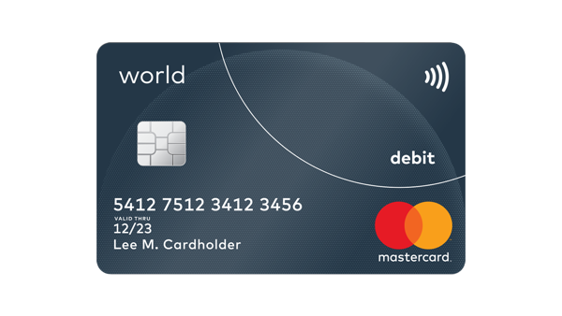

Customer service call +1234567890,+0987654321

Lorem ipsum dolor sit amet ,consectetur adipiscing elit ,sed do eiusmod tempor incididunt ut labore et dolore magna aliqua .ut enim ad minim venai .

mastercard

Lee M. Cardholder

12/23

Valid thru

5412 7512 3412 3456

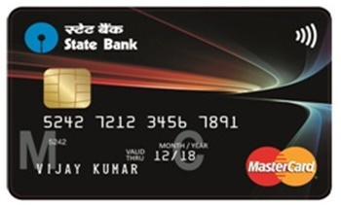

world



123

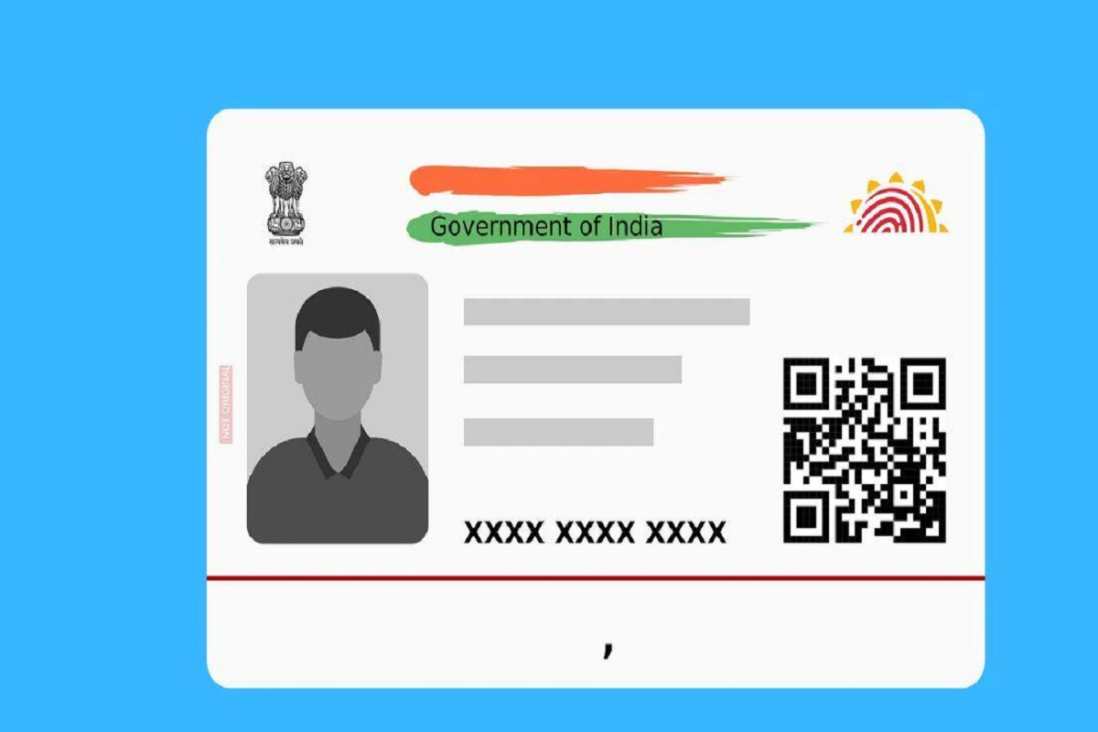

PHOTO

 NAME:SHIN RYUJIN

AGE: 22

GENDER: FEMALE

1234 5678 9012

## AADHAR APKI PEHCHAN